**project Design Phase-II Technology Stack (Architecture & Stack)**

|  |  |
| --- | --- |
| Date | 18 October 2022 |
| Team ID | PNT2022TMID30922 |
| Project Name | Virtual Eye – Life Guard For Swimming Pools To Detect Active Drowning |
| Maximum Marks | 4 Marks |

**Technical Architecture:**

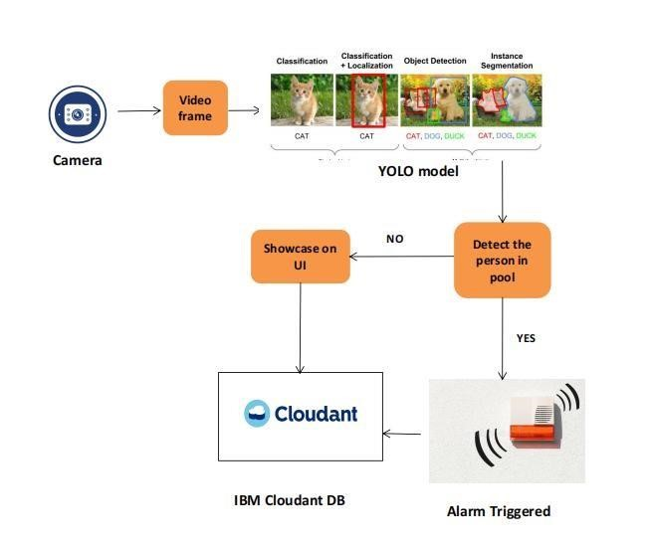

**Table-1 : Components & Technologies:**

|  |  |  |  |
| --- | --- | --- | --- |
| **S.No** | **Component** | **Description** | **Technology** |
| 1. | User Interface | Web UI or Website | HTML, CSS, JavaScript / React JS |
| 2. | Application Logic-1 | Model building and training | Python |
| 3. | Application Logic-2 | Getting Video frame from user for prediction | IBM Watson STT service |
| 4. | Application Logic-3 | Fetch the relevant data from the database and project them to user | IBM Watson Assistant |
| 5. | Database | Video frame or Image data of the swimmer's body movements | MySQL/NoSQL |
| 6. | Cloud Database | Fetch data from database and feed them to model for prediction and also used to retrieve the data required for user. | IBM DB2, IBM Cloudant etc. |
| 7. | File Storage | Image data, login credentials and API keys | IBM Block Storage |
| 8. | External API-1 | To get the data from the database when swimmers in the pool | IBM Storage API |
| 9. | External API-2 | To get the username and password | Authentication API, etc. |
| 10. | Deep Learning Model | To predict the drowning people through the video input | Image Recognition Model, YOLOv7 model. |
| 11. | Infrastructure (Server / Cloud) | Application Deployment on Cloud Server | Cloud Foundry |

**Table-2: Application Characteristics:**

|  |  |  |  |
| --- | --- | --- | --- |
| **S.No** | **Characteristics** | **Description** | **Technology** |
| 1. | Open-Source Frameworks | Anaconda open source framework | Python |
| 2. | Security Implementations | Computer vision based monitoring system | Artificial Intelligence |
| 3. | Scalable Architecture | To scale our system software on the server side by supporting clients | IBM Auto Scaling |
| 4. | Availability | 24/7 monitoring system | IBM Cloud load balancer |
| 5. | Performance | Designing the system software that can monitor a wide range of swimming pool at a time without any delay and to provide accurate predictions | IBM instance |